Supporting Information
Life on the edge: industrial footprint and edge effects variably influence the spatial distribution of a boreal small mammal.

Equation S1: The general format of generalized linear mixed models with a proportional binomial distribution and logit-link function used to model red squirrel responses to landscape structure. Squirrel presence_{ij} was the monthly occurrence of a red squirrel at site i in array j with n_{ij} total monthly trials. In each model, β_{n} was the linear coefficient for landscape covariate x_{n}, and v_{i(j)} and u_{j} were nested random intercepts of site and array, which were assumed to have a normally distributed variance. All models were fit using the glmmTMB package (Magnusson et al., 2017) using maximum likelihood with the Laplace approximation. All explanatory variables were scaled using standardized z-scaling to improve model convergence and facilitate comparison of relative effect sizes.

$$η_{ij}=β_{0}+ β_{1}x_{1,ij}+…+ β_{n}x_{n,ij}+ u_{j}+ v_{i(j)}$$
$${logit(μ}_{ij})=\ln\left(\frac{μ_{ij}}{1-u_{ij}}\right)=η_{ij}$$
$${Squirrel presence}_{ij} \sim Binomial(n_{ij}, μ_{ij})$$
$$u_{j} \sim Normal(0, σ_{u}^{2})$$
$$v_{i(j)} \sim Normal(0, σ_{v}^{2})$$

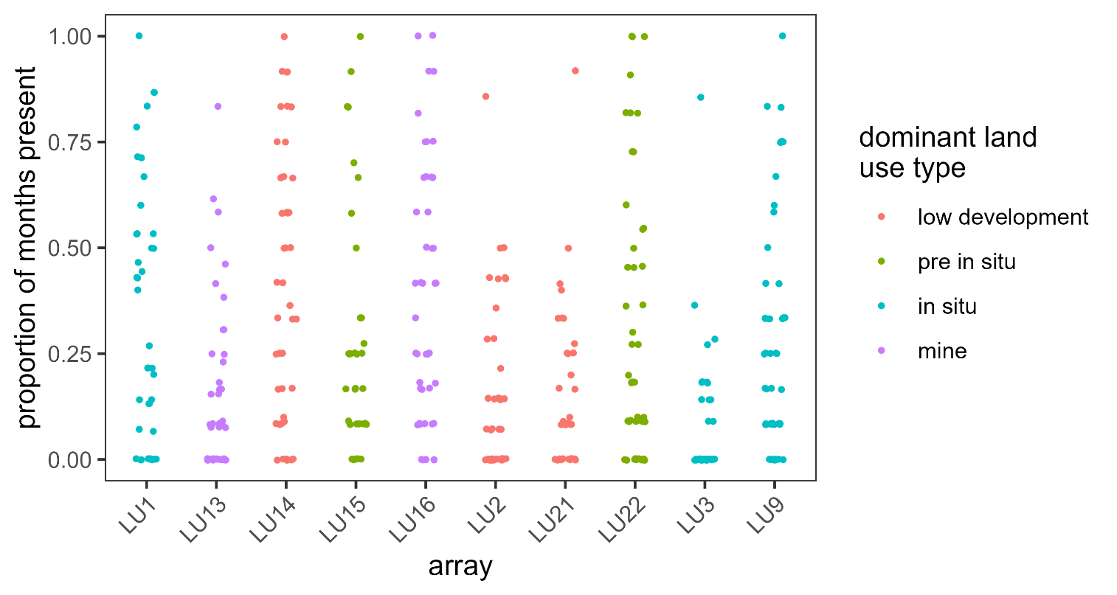

Figure S1. Distribution of the proportion of months of red squirrel were present for 430 camera trap sites distributed across 10 Landscape Units (“array”). Our final monthly dataset represented 4,918 camera-months of data and a total of 1,309 months with squirrels present.

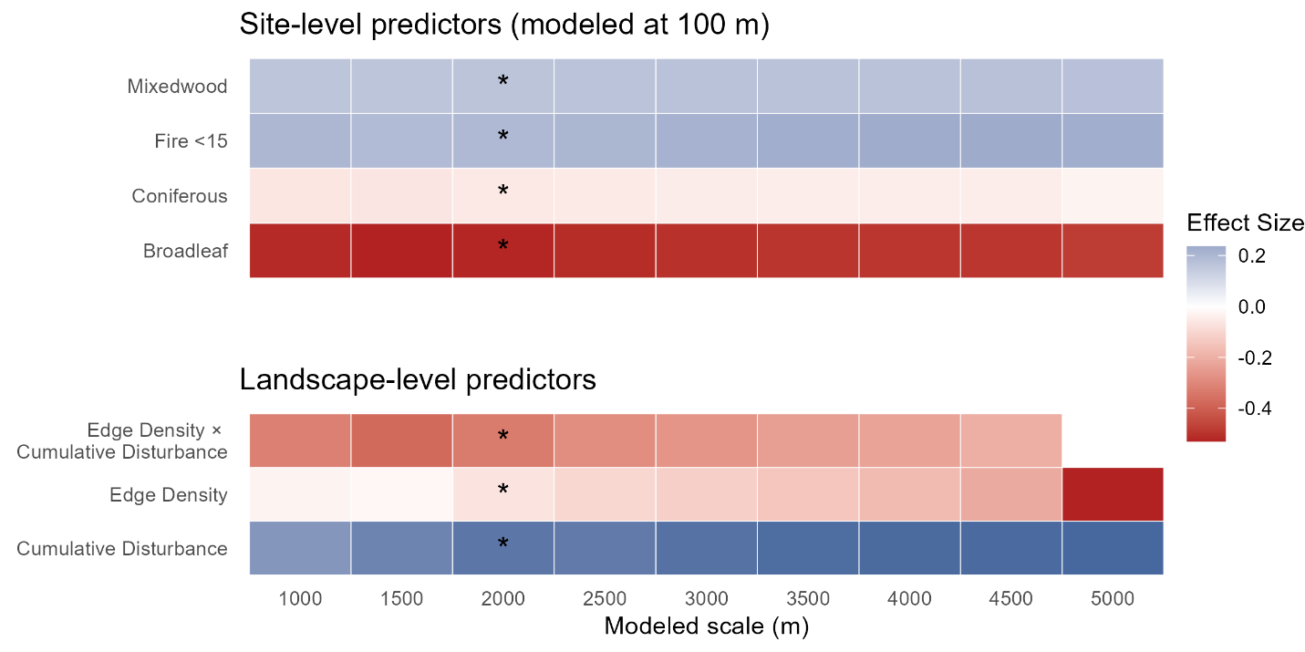
Figure S2. Sensitivity analysis depicting effect sizes for the top-performing models (lowest AICc) at all spatial scales. Natural landcover at the site-level was always constrained to 100-m, while landscape-level predictors were refit at ten spatial scales using concentric circular buffers ranging from 1000-m to 5000-m radii, in 500-m increments. Models were fit using mixed-effect proportional binomial models with nested random effects for camera site and Landscape Unit. Effect sizes for landscape-level predictors were largely consistent across all modeled spatial scales, with the exception of the 5000-m scale where the top-performing model (based on AICc) did not contain an interaction between edge density and cumulative industrial footprint.

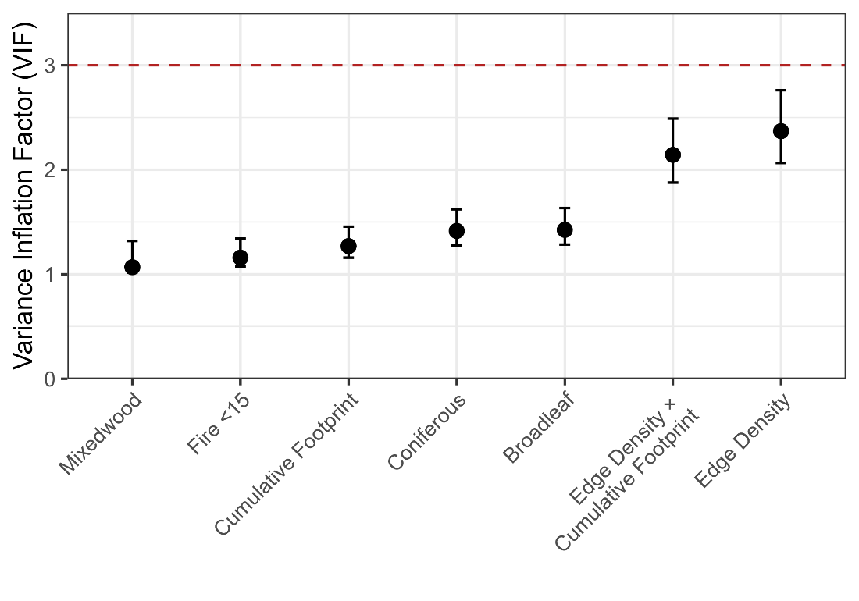
Figure S2. Variance inflation factors (VIFs) for the top-performing model explaining red squirrel monthly occurrence as a function of natural land cover, edge density, and cumulative industrial footprint. The model was fit as a mixed-effect proportional binomial model with nested random effects for camera site and Landscape Unit.
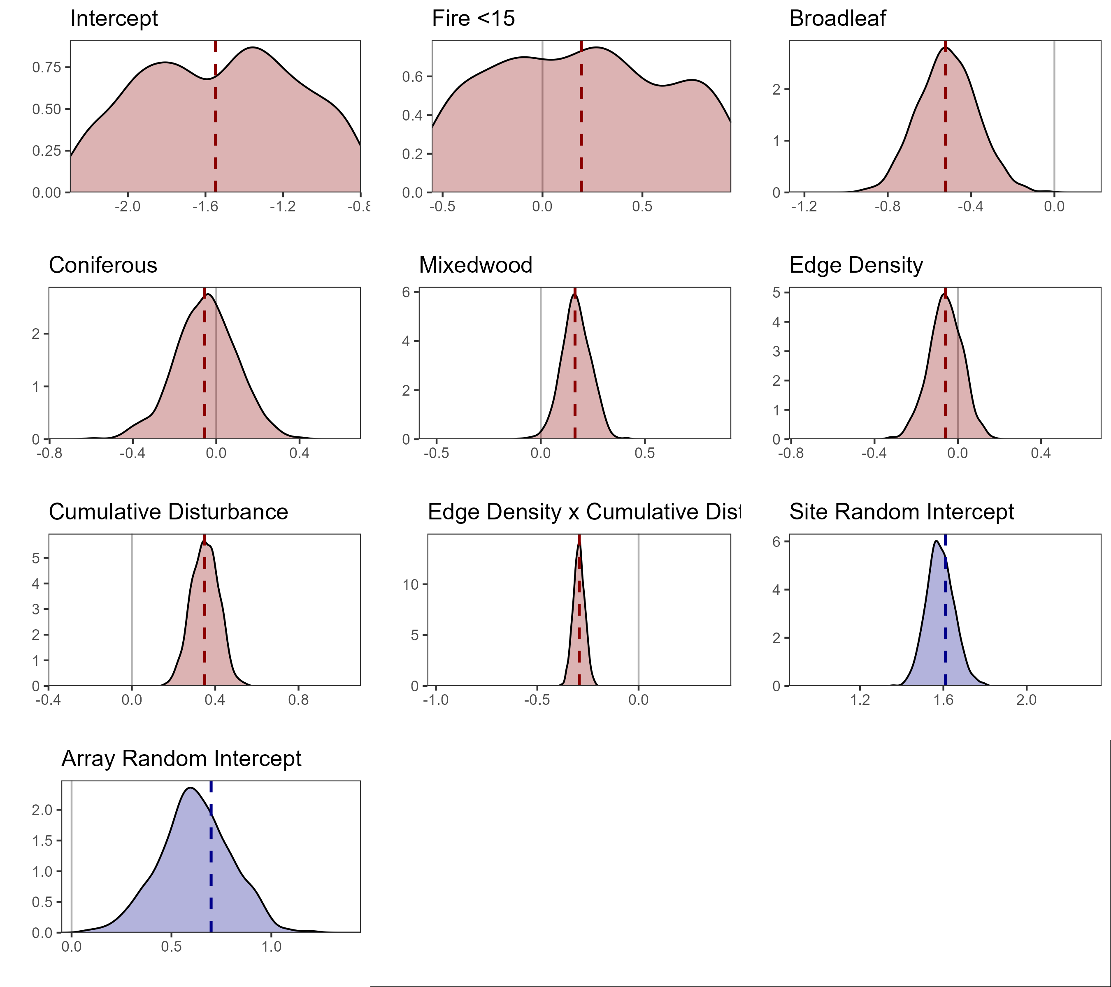Figure S3. Density of coefficient estimates (red) and random intercept variance estimates (blue) for 1000 fitted models of red squirrel monthly presence as a function of landscape structure. Data for simulations was generated using the top-performing model from model selection as a ‘true’ data-generating process. For a hypothetical scenario of 10 arrays and 43 cameras per array, we simulated 1000 new datasets by sampling landscape covariates from their observed distributions and generating squirrel detections for each camera site using the random variance structure and proportional binomial distribution from our top-performing model. We refit the model to each simulated dataset to build an empirical distribution of coefficient estimates, then assessed the empirical precision (standard error) and bias (mean) of our fixed effect and random effect estimates compared to the top model (Zuur et al., 2016). Dotted vertical lines represent the coefficient/variance from the ‘true’ data generating model.

Table S1. Covariates describing the composition of natural habitat, composition of anthropogenic features, and landscape configuration in negative binomial models of red squirrel abundance in the Boreal Plains. Each category of covariates was included in models at a separate spatial scale. Within each category of predictors, we fit a model using all predictors at 22 spatial scales (50 m–5000 m) and compared the Akaike Information Criterion corrected for small sample size (AICc) scores across spatial scales to determine which one was best supported for statistical modelling.

Covariate | Modelled Scale | Median (5%, 95%) | Description
Natural land cover | 100 m
Fire <15 |  | 0.00 (0.00–0.61) | Proportion cover of fires from 0 to 15 years of age and any intensity.
Broadleaf |  | 0.03 (0.00–0.81) | Proportion cover of broadleaf forest (>75% broadleaf canopy cover).
Coniferous |  | 0.35 (0.01–0.85) | Proportion cover of coniferous forest (>75% conifer canopy cover).
Herbs |  | 0.00 (0.00–0.15) | Proportion cover of herbacous plants.
Mixedwood |  | 0.03 (0.00–0.33) | Proportion cover of mixedwood forest. (Neither >75% broadleaf nor >75% mixedwood canopy cover).
Shrubland |  | 0.00 (0.00–0.13) | Proportion cover of shrubby plants.
Wetland |  | 0.01 (0.00–0.31) | Proportion cover of wetlands.
Treed Wetland |  | 0.15 (0.00–0.72) | Proportion cover of treed wetlands (e.g., spruce bog).
Disturbance composition | 4250 m
Cumulative Footprint |  | 0.04 (00.00-0.19) | Sum of the footprint of all anthropogenic disturbances in the surrounding matrix.
Roads |  | 0.00 (0.00–0.01) | Proportion cover of roads (paved and unpaved).
Seismic Lines |  | 0.01 (0.00–0.03) | Proportion cover of all conventional and low-impact seismic lines.
Active Well Sites |  | 0.00 (0.00–0.02) | Proportion cover of well sites pre-cleared for drilling or actively used for drilling.
Inactive Well Sites |  | 0.00 (0.00–0.02) | Proportion cover of reclaimed, restored, or abandoned well sites.
Industrial Facilities |  | 0.00 (0.00–0.08) | Proportion cover of industrial sites (mines, processing facilities, tailings ponds).
Harvest <15 |  | 0.00 (0.00–0.10) | Proportion cover of timber harvest blocks from 0 to 15 years of age.
Pipelines & Transmission Lines |  | 0.01 (0.00–0.05) | Proportion cover of pipelines and transmission lines.
Landscape configuration | 2250 m
Edge Density |  | 71.19 (13.86–279.67) | Total density of natural habitat edges created by anthropogenic disturbances (m/Ha).
Mesh Index |  | 126.03 (41.22–438.25) | Mean patch size adjusted for landscape area. Represents patch size.
Cohesion |  | 99.59 (98.17–99.96) | Probability of any two points of natural habitat being connected. Represents connectivity.
Shannon's Evenness |  | 0.64 (0.41–0.82) | Evenness of land cover types (composition). Represents land cover dominance.

Table S2. Spearman’s correlation (r) where |r|> 0.50 for the final dataset used to model red squirrel detections. Roads were not included in any models due to their high correlation with other disturbance metrics. The effect of other correlated variables was assessed using model diagnostics and variance inflation factors after model fitting.
Covariate 1 | Covariate 2 | r
Seismic Lines | Edge Density | 0.953801
Edge Density | Cohesion | -0.90604
Seismic Lines | Cohesion | -0.90533
Industrial Facilities | Cumulative Footprint | 0.816844
Roads | Cumulative Footprint | 0.711041
Roads | Active Well Sites | 0.657172
Well Sites | Cumulative Footprint | 0.637921
Pipelines & Transmission Lines | Cumulative Footprint | 0.617681
Harvest <15 | Harvest | 0.604208
Edge Density | Cumulative Footprint | 0.590482
Inactive Well Sites | Cumulative Footprint | 0.569573
Inactive Well Sites | Edge Density | 0.566548
Active Well Sites | Cumulative Footprint | 0.559706
Pipelines & Transmission Lines | Roads | 0.551207
Cohesion | Cumulative Footprint | -0.54496
Active Well Sites | Inactive Well Sites | 0.52936
Broadleaf | Coniferous | -0.50826

